Report on Celebration of International Day for Biodiversity in Sudan on 22nd May 2018

The celebration of the International Day for Biodiversity (IDB) is considered as an opportunity for awareness raising on the importance of the biodiversity and its conservation. The theme of this year 2018 is "Celebrating 25 Years of Action for Biodiversity".

At the national level, the celebration of IDB was organized by the Higher Council for Environment and Natural Resources - Ministry of Environment, Natural Resources and Physical Development under the theme of this year 2018 "Celebrating 25 Years of Action for Biodiversity". Several institutions participated in this event including, Local communities and private sectorز

Sudan country plans to celebrate nationally this day in multifold approach, in this regard a high committee was formed to organize a celebration in Sudan, consequently sub committees were split and assigned for different tasks.

The Biodiversity National Committee Prepared a plan for this event including different activities among them;
- Success stories and best practices on implementation of CBD objectives to highlight progress made in the achievement of its objectives at the national level
- Exhibition by various organizations
- Production of awareness materials on biodiversity
- Declaration of the establishment of biodiversity database

Success stories

The success stories committee is mandated to undertake the communication of knowledge and best practices. As well to arrange for a knowledge share day, which will gather experts and practitioners, local people and others to exchange ideas and share best practices done in the past period, highlighting the conservation and sustainable use of biodiversity and the equitable sharing of benefits from the use of genetic resources. A call for Biodiversity Awards 2018 was made by the committee to identify the national successes in implementing the convention. Other objectives are: Awareness raisingand documentation and publication of the best practices

A workshop was organized to present success stories and then to distribute awards for the three top success stories. The Minister of Environment addressed the workshop in the opening session reflecting the commitments taken by the government including adoption of National Biodiversity Strategy and Action plan and the importance of its mainstreaming in the national development plans. The secretary general also addressed the workshop highlighting the importance of coordination and information sharing for conservation of biodiversity. He reflected the newly established of national biodiversity database

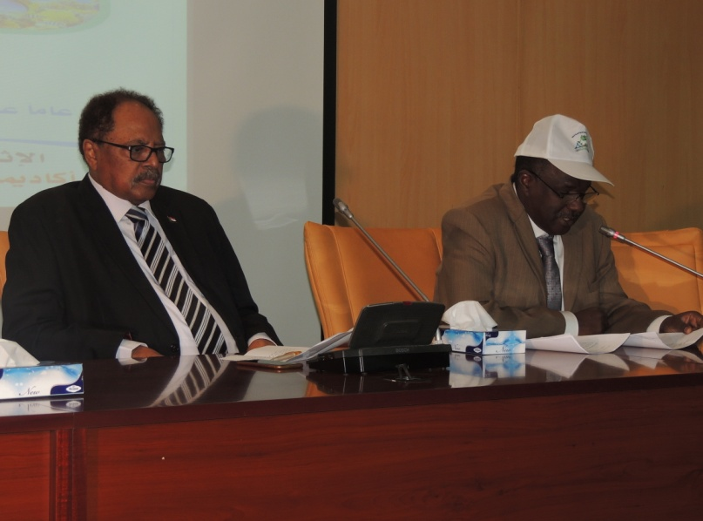

A presentation on the national the implementation of the Convention of biological Diversity, achievements and challenges for the implementation was made by the coordinator of biodiversity Dr. El Khitma El Awad. The distinguished winners also presented the best practices

Advocacy messages

During the event Six advocacy messages directed the president and parliaments to support the national law on Access and Benefit Sharing were submitted to the minister .

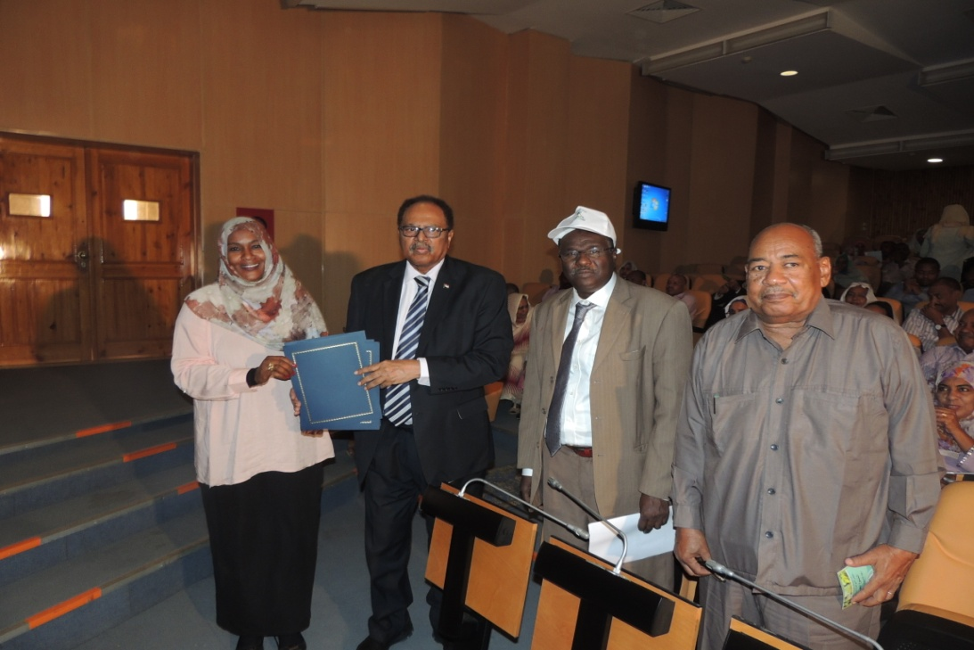
The minster of Environment received the advocacy messages

In the last session of the workshop the minister presented awards to the winners of the best three success stories.

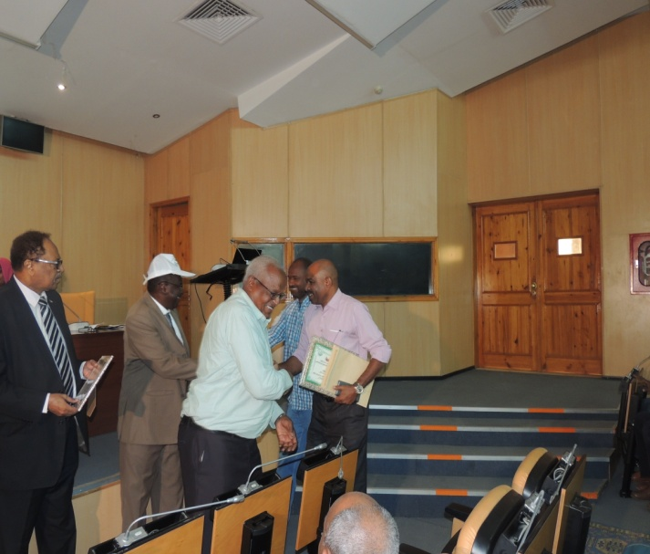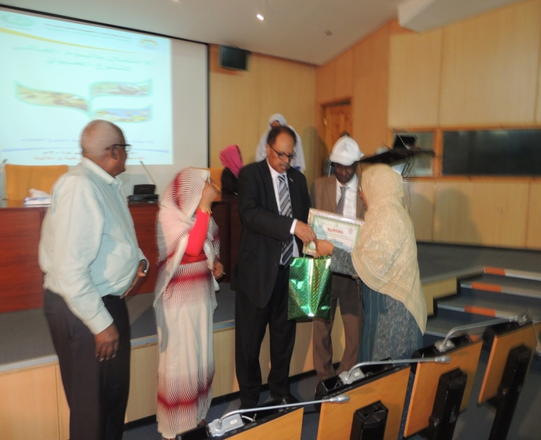

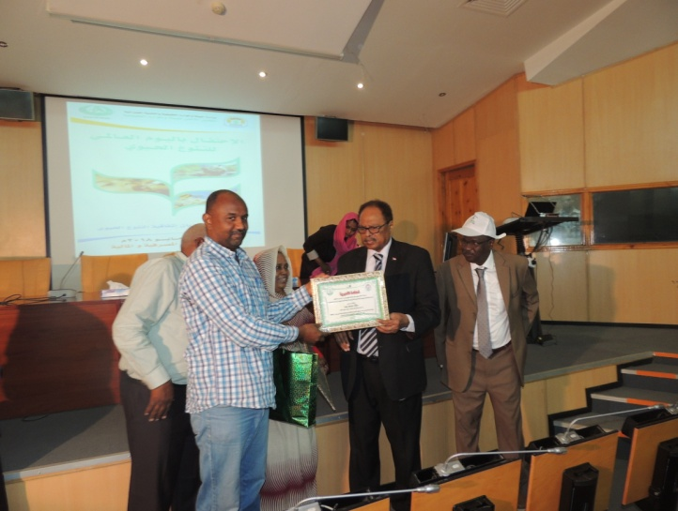
The minister of Environment presented awards to the winner of success stories

Exhibition
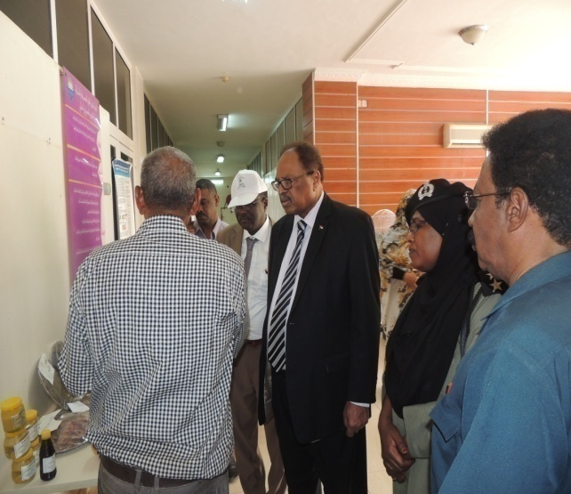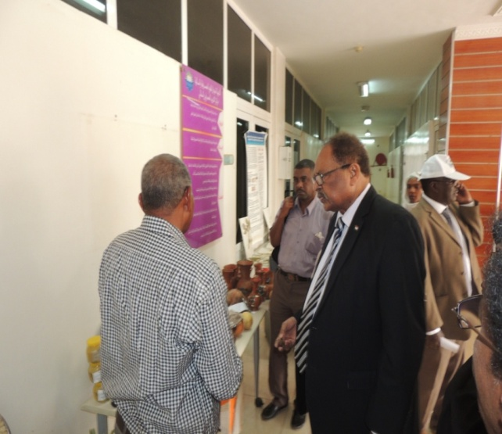
The minister of environment and the Secretary General of HCENR in the Exhibition of the local community

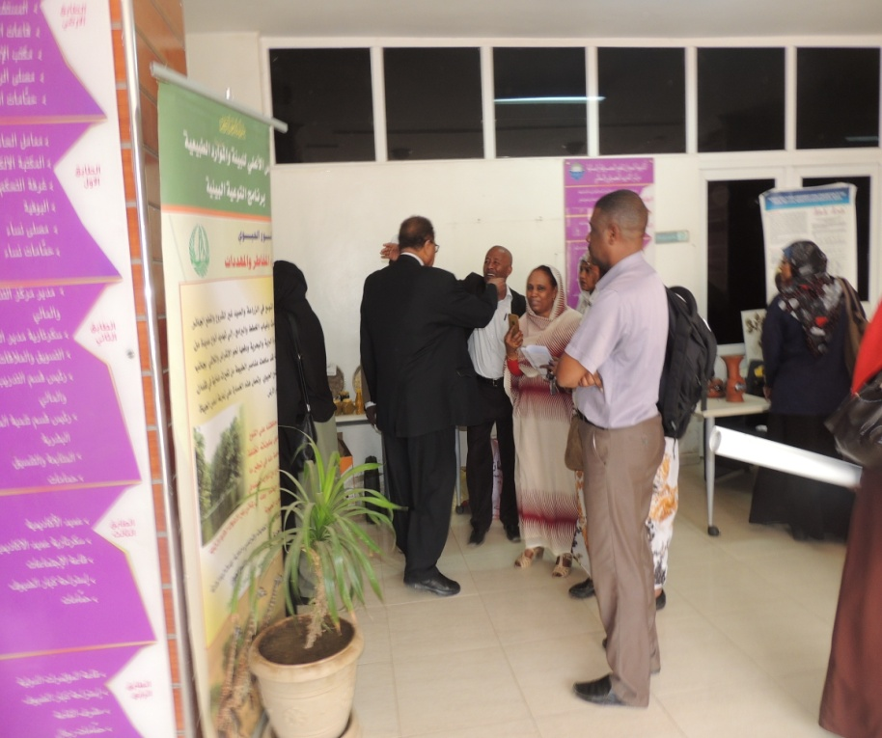
Part of Exhibition

Brochures and other communication materials covering national efforts for conservation of biodiversity were produced.





